HOTEL ROOM RESERVATION FORM
VLSI Conference in January 2023

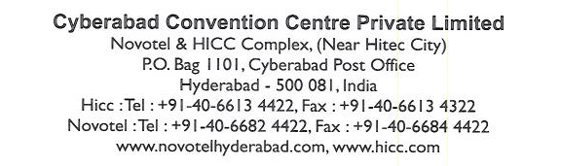
Reservations department details
E-mail: h6182-re@accor.com ; h6182-sl23@accor.com
Please email filled form to e-mail ids provided above.
*Please note: room type & rates will be subject to availability at the time of confirmation.

Complete Details in Full
Title | : | Mr. / Mrs. / Ms. / Dr. (Remove what is not applicable)
First Name | :
Last Name | :
Tel. No. / Mobile No. | :
E-mail id | :
Airport Pick-up | : | Required / Not Required (remove what is not applicable)
Airport Drop | : | Required / Not Required (remove what is not applicable)
If you need Airport pick & Drop, provide flight details | : | Flight No. (Arrival) | Arrival Time : | Arrival Date: | Flight No. (Departure) | Dep. Time : | Dep. Date :
Check-in Date & Time | :
Check-out Date & Time | :
Room Type | : | Superior Room (Single or Double) @ INR 7500+ taxes per night
No. of Rooms | :

Superior Room includes the following facilities:
- Complimentary buffet breakfast at food exchange.
- Complimentary in room Wi-Fi internet.
- Complimentary usage of health club facilities.
- Usages of swimming pool when it’s functional.
- Complimentary tea/coffee maker in the room.
- Complimentary two bottles of mineral water.
- In-room electronic safe.

*We are pleased to offer airport transfers at INR 4000 AI per way per car. Request you to kindly mention the flight details & tick / circle on the airport transfers request mentioned above to enable us to arrange the same

Terms and conditions
- The above rates are on per room per night basis.
- Applicable taxes extra.
- Government authorized id proof is mandatory for Indian nationals and valid passport and visa is mandatory for foreign nationals to carry for check-in.
- The check in time is 1400hrs and the check-out time is 1200hrs, early check-in and late check-out is subject to availability.
- The bookings are non-amendable, non-cancellable and non-refundable.

credit card guarantee (as per terms & conditions)

mandatory for reserving the room
- American Express |  | - MasterCard | - Visa
Card no.: |  |  | Expiry Date: | (dd-mm-yy)
Cardholder’s name on credit card: |  |  | Signature:

