Present with your video beside your PowerPoint slides in Microsoft Teams or Zoom

Reference for More Details: <https://www.youtube.com/watch?v=rKDKniBmwe0>

1. Presenters need to use **uniform background while presentation recording** and need to **ensure proper bright lighting condition is maintained**
2. **Have a Clean Windows Background:**
   * Have a Black Solid Background on Windows Background
     + - Solid background should be **black** to match the below mentioned camera app
       - Use Desktop 🡪 Personalization 🡪 Background to set desktop background. Screenshot below

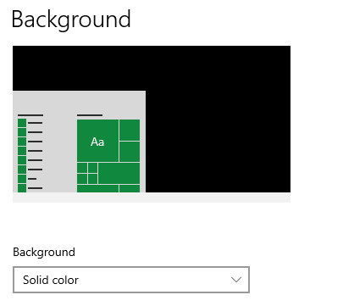

* + Hide all the Desktop Icons

Right click on anywhere on the open part of the desktop in the view item.

**Uncheck show desktop icons** so all the desktop icons go away. Screenshot below

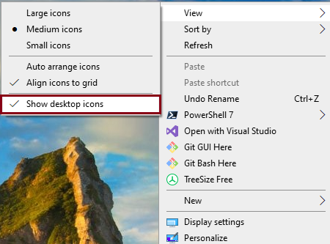

* + Clean up any apps that you are running now. Minimize the basic ones that you need.
  + Hide the taskbar

Right click and we go to taskbar settings so then it opens up the taskbar settings we want to do two things first of all turn the lock of the taskbar off and secondly turning automatic height if you move your cursor down to the bottom it comes back up but if you leave your cursor in one spot then it will disappear taskbar settings are automatically hide the taskbar

* Right click, select “Taskbar Settings”. Snapshot below



* Enable “Automatically hide the taskbar in desktop mode” . Snapshot below

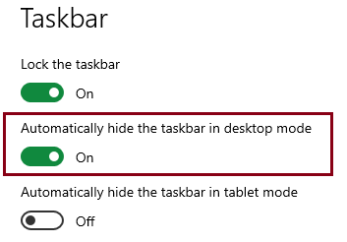

1. **Setup PowerPoint**
   * In the slideshow ribbon go to setup show and change it from the default full screen to **browse by an individual window**. What this does it it's going to run the slideshow in this window determine what part of the screen is the slides input video any other part of the screen so click OK.
2. **Open up Windows Camera App**
   * We are not actually going to use it to record video we're just going to use it as a preview so that we have essentially the video feed on the screen.

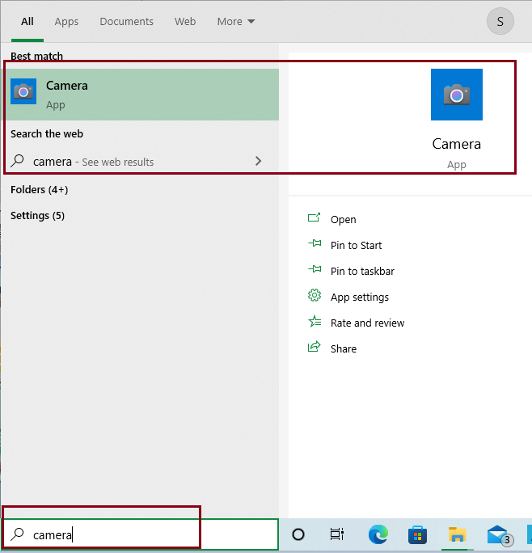

* + Move to video mode in Camera app and keep the left side

1. **Setup the desktop Arrangement**
   * Put the video on the left hand side and Powerpoint slides on the right hand side.

Drag the video camera off the left side of the screen and moves it so it's essentially cropping off all those icons on the left hand side.

To crop off the icons on the right hand side, take the PowerPoint window and size it so that you have got that required side-by-side

Go into slideshow mode from the beginning of the slides.

1. **Open MS Teams or Zoom**
   * Share the entire desktop, don’t have the camera enabled on MS Teams/Zoom
   * Now you will have your video being shown next to your slides.
   * Start recording and start your presentation.
2. **Final recorded screen should look like below.**
   * Ensure video is not covering more than 20% of the overall screen width

